Team P&Y
Members: Deduyo, Benebaye

Project Description:
DAIAMONDO is a multi-purpose platform that offers users a streamlined experience for car dealership, rental, and servicing—all in one app. The platform integrates a smart AI assistant to provide real-time help and guidance, allowing users to efficiently browse, book, and manage their automotive needs. Designed with flexibility, security, and user satisfaction in mind, DAIAMONDO transforms the traditional vehicle transaction process into a smooth, digital-first experience.
By incorporating vehicle listings, rental schedules, service bookings, and smart chatbot support, DAIAMONDO ensures users can find the right vehicle, book necessary repairs, or seek assistance through an intuitive, easy-to-use system.

Requirements Summary:
Functional Requirements
- User Authentication
  - Users can create an account and log in using email, Facebook, or Google.
  - Secure login credentials are required for access.
- Home Dashboard
  - Displays featured or recommended cars.
  - Quick access to navigation tabs: Buy, Rent, Sell, Services, Inbox, AI Chatbot, Profile, and Cart.
- Car Buying
  - Users can browse available cars for sale.
  - Each listing includes car specifications, pricing, seller contact, and image carousel.
  - Users can add cars to their cart and proceed to check out.
- Car Rental
  - Users can view available cars for rent with map-based pickup points.
  - Option to select time, duration, and location for rental.
  - Real-time booking interface with pricing and confirmation.
- Car Selling
  - Users can list their car by entering car details (make, model, condition, price, mileage, etc.).
  - Graph showing listing performance or transaction history is included.
- Service Booking
  - Users can book services such as diagnostics, oil change, tire change, and full car wash.
  - A service dashboard displays upcoming bookings and history.
- Inbox and Messaging
  - Users have access to a messaging center to communicate with buyers, renters, or service providers.
  - Messages are threaded per user with timestamps.
- AI Chatbot (adamant.ai)
  - Persistent access to chatbot across app.
  - Handles user queries for bookings, listings, and general help.
  - Conversational UI for instant assistance.
- Profile Management
  - Displays user profile, active listings, and transaction history.
  - Allows editing of personal details and viewing user activity.
- Cart and Checkout
  - Users can add cars to the cart, review item details, and confirm purchases.
  - Shows total price and allows final checkout via the “Confirm Purchase” button.
- Search and Filters
  - Listings and rentals can be filtered by type, price, proximity, and condition.
- Map Integration
  - Rental service integrates location maps for vehicle pickup/drop-off and routing.
- Transaction History
  - View previous rentals, services, and purchases under “Recent Transactions.”
Non-Functional Requirements
- Security
  - All user data, including transactions and profile information, must be encrypted.
  - Login and checkout must follow secure authentication protocols.
- Usability
  - The app features a minimal, highly visual pink-toned UI for brand consistency and accessibility.
  - Icons and quick-access menus improve navigation.
- Responsiveness
  - All features and components should function on both mobile and tablet devices with appropriate resolution scaling.
- Performance
  - Page transitions, chat responses, and map loads should occur with minimal delay (<2 seconds under average network conditions).
- Availability
  - The app must be accessible 24/7 with proper error handling and fallback for network issues.
- Scalability
  - The platform should support future addition of features like insurance booking, premium user badges, or referral programs.
- Maintainability
  - UI components should follow modular design to allow updates or redesign without affecting system-wide performance.
- AI Integration
  - Chatbot must remain context-aware and capable of rerouting to human support when needed.
  - It should be trained in app FAQs and transaction-related queries.

Design Space:
DAIAMONDO’s design revolves around optimizing the user experience for vehicle sales, rentals, and services within one platform. The platform must balance a feature-rich environment without overwhelming the user, supporting both quick access to essential services and robust back-end handling of real-time inventory and scheduling.
One major challenge is structuring the booking system to avoid overlapping appointments or rental conflicts, especially during peak demand. Similarly, building a responsive chatbot that provides meaningful, accurate help while feeling conversational is essential.
Design considerations also involve providing intuitive navigation, clear data display (like vehicle specs or service details), and seamless integration of payments, ratings, and booking flows. Trust mechanisms such as verified listings and user reviews must be embedded in a way that promotes transparency.
Simple tasks like searching for a car, signing in, or checking service availability are straightforward. More complex features include dynamic rental/service booking logic, AI chatbot behavior tuning, and cross-integration of user history with ongoing transactions.

Design Summary:
We initially considered separating the dealership, rental, and service features into standalone apps to reduce complexity. However, this would fragment the user experience and limit the synergy between features. A unified app ensures convenience and better data integration.
We also evaluated whether to use a minimal interface with quick-access tabs only, but this proved to hide essential community features like reviews and customer feedback. Instead, we adopted a balanced design where transactional speed coexists with rich service and reputation visibility.
A fully human-only customer support approach was also explored but later rejected in favor of a hybrid AI-human system. While AI handles FAQs and navigation help, escalated issues go to human agents to ensure fairness and empathy.
Finally, we decided to implement service reminders, smart recommendations, and rental alerts, which evolved from initial user testing that highlighted the importance of time-sensitive notifications.
Scenarios
Scenario 1 – John, a first-time car renter, struggles to find trustworthy online car rental options.
After encountering hidden fees and poor customer support from other services, John discovers DIAMONDO. The app's smooth interface allows him to browse verified cars near his location, and the real-time AI chatbot answers his concerns instantly. With features like upfront pricing, user reviews, and instant booking, John confidently rents a Ford Puma for his weekend trip. He appreciates how transparent and easy DIAMONDO makes the process compared to traditional rental platforms.
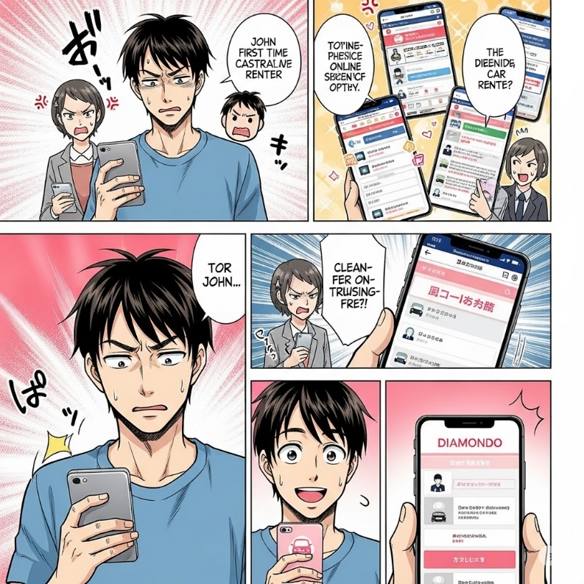
Scenario 2 – John & Sarah, a college student with a part-time job, is in search of a budget-friendly yet reliable used car to buy.
John's transition from frustration to satisfaction with car-related services. He first appears overwhelmed, possibly by the complexity of existing options, and sees various problematic apps on other phones. His expression then shifts to hope as he encounters the DIAMONDO app. Another person, Sarah, seems to highlight its clean, user-friendly, and free nature. Finally, John is shown happily and confidently using the app, which is presented with a distinct pink themed and clear features, signifying his positive experience and newfound trust in DIAMONDO as a comprehensive solution. The trustworthy environment and streamlined process assured her she made the right decision.
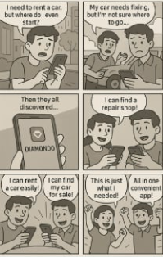
The Designs:
Design 1 (Pink UI)
Overview:
DAIAMONDO's pink interface showcases a vibrant, consumer-friendly approach with prominent promotional banners and visual car displays. The home screen features personalized greetings, special discount offers, and a "Recommended Cars" section with detailed vehicle cards showing specifications like mileage, price, and transmission type. The bottom navigation provides quick access to core functions through intuitive icons for home, favorites, messaging, profile, and services.
Scene:
Luis opens the app and immediately sees a "Special 40% Discount for New Users" banner with an attractive car image. He scrolls down to "Recommended Cars" where he finds a Volkswagen Golf listing with clear details: 25,000 KM mileage, ₱2,500/HR price, and automatic transmission. He taps "VIEW ALL" to explore more options, then uses the bottom navigation to access his favorites or start a conversation with dealers.
Assessment:
Advantages:
- Eye-catching promotional elements drive user engagement
- Clear vehicle information cards with essential details upfront
- Warm, approachable pink color scheme builds trust
- Personalized user experience with location-based greetings
- Easy navigation with recognizable bottom tab icons
Disadvantages:
- Heavy promotional content may overwhelm users seeking quick browsing
- Pink color scheme might not appeal to all demographics
- Dense information layout could cause visual fatigue
Requirements Met:
- Streamlined vehicle discovery with detailed listings
- Integrated promotional system for business growth
- User-friendly mobile interface with clear navigation
- Trust-building through transparent pricing and specifications

Design 2 (Blue UI)
Overview:
The blue interface emphasizes professionalism and functionality with a clean, structured layout. Multiple screen variations show comprehensive user flows from browsing to booking, with consistent blue theming throughout. The design focuses on information hierarchy and systematic organization, presenting vehicle listings, user profiles, and booking interfaces with clear visual separation and professional aesthetics.
Scene:
Bianca launches the app and navigates through the streamlined blue interface. She browses through systematically organized vehicle listings, each presented in clean cards with consistent formatting. The professional blue theme guides her through the booking process with clear step-by-step screens, from selection to confirmation, maintaining visual consistency throughout her journey.
Assessment:
Advantages:
- Professional blue color scheme appeals to business users
- Consistent design language across all screens
- Clear information hierarchy reduces cognitive load
- Systematic organization supports efficient decision-making
- Comprehensive user flow coverage from browses to book
Disadvantages:
- More conservative approach may lack visual excitement
- Could appear less engaging for casual consumer users
- Blue-heavy palette might feel monotonous over extended use
Requirements Met:
- Professional interface suitable for business transactions
- Comprehensive booking and management workflows
- Consistent user experience across all touchpoints
- Clear information architecture supporting quick decisions

Design 3
Overview:
This design centers around visual simplicity and task focus. It separates user flows by goal: "I need a car," "I want to sell," or "I need service." Each path leads to a tailored sub-page. The listing interface supports swiping cards with quick compare options. Messaging and negotiation happen within a dedicated chat.
Scene:
Luis sees the homepage prompt: "What would you like to do today?" He selects "I need a car." The app shows filtered rentals based on location. He selects one, messages the host for clarification, and finalizes the booking with in-app payment.
Assessment:
Advantages:
- Clean layout guides decisions
- Filters and categories reduce decision fatigue
- Chat-based negotiation encourages human connection
Disadvantages:
- Extra step for each goal may slow down expert users
- Messaging system needs moderation
Requirements Met:
- User segmentation based on intent
- Robust communication and trust framework
- Filtered, curated browsing

Requirement Changes:
The design evolution from pink to blue represents a strategic shift from consumer-focused marketing to professional functionality. The pink design prioritizes user acquisition through promotional elements and engaging visuals, while the blue design emphasizes operational efficiency and professional credibility. User feedback indicated the need for both approaches depending on user context - promotional pink for new user acquisition and professional blue for repeat business users.
Based on the wireframe analysis, we separated the visual approaches to serve different user segments while maintaining core functionality. The pink interface targets individual consumers with emotional appeal and promotional offers, while the blue interface serves business users and frequent customers who prioritize efficiency and professional presentation.
Final adjustments balanced visual appeal with functional clarity, ensuring both designs support the core DAIAMONDO experience while serving their respective user bases effectively. The dual-design approach allows the platform to adapt its presentation based on user type and context, maximizing engagement across different market segments.

